

Greenbank Falmouth Rowing Club

Regatta 2026

Safety Information
Incident Procedure
Risk Assessment
for Regatta officials, club officials and competitors

Introduction
Greenbank Falmouth Rowing Club (GFRC) Regatta is held at the club’s base, Stithians Lake, near Redruth. Please note that:
- safety cover is provided by Club members who know the water well and with emergency backup if required from Stithians Water Sports Centre.
- we are using a combination of our own kit and other resources hired from South West Lakes;
- the whole regatta course is visible from the bank and safety area;
- the lake is hired exclusively for the duration of the regatta, therefore there are no other water users or craft and moored boats are moved from the warm-up/racing area;
- there are no tides or currents.
The Regatta is held under British Rowing Rules of Racing and the guidance given in the British Rowing Row Safe Guide. All clubs and competitors should understand and adhere to these documents. We endeavour to make this event as safe as possible, but please remember that your safety is your responsibility.
Trailer and vehicle parking
On arrival at the entrance to Stithians Lake, please proceed along the lane, observing the 5mph speed limit where indicated and park vehicles and trailers in the car park next to the Greenbank Boathouse. Drivers should note that there is a children’s play area in front of the main building and a campsite to the right. Please take due care.
The course
Stithians Lake provides a straight, approximately 1000 metre course. The number of crews racing side-by-side is reviewed at each regatta in light of the current water level. All competitors and particularly coxes should be aware of the circulation pattern and racing course as shown later in this document and in the regatta programme. This will also be described at the Captains and Coxes briefing which will take place in front of the main Watersports Centre building at 10.15am.
The start will be at the far end of the lake as indicated on the map on page 3 and in the regatta programme. Crews should make their way to the start as indicated by the dotted line on the map. When the water level is low, crews must take extra care when passing the point of land that juts out on the way up to the start and around the edge of the lake where there may be rocks close to the surface. Hazards will be pointed out at the Captains and Coxes briefing. Crews must stay inside the buoy that is situated off this point to stay off the course. Any crews causing a safety issue by getting in the way of racing crews will risk disqualification.
The racing stations will be numbered from the starboard side i.e. the lowest numbered crew will always be on starboard. The outer edges of the racing course will be indicated beyond the finish line by two large buoys, opposite the main building. It is not mandatory for crews to pass between these buoys. The finish line will be indicated for the finish umpires by a post in front of the finish tent and a corresponding post on the opposite bank of the lake.

Stithians Lake
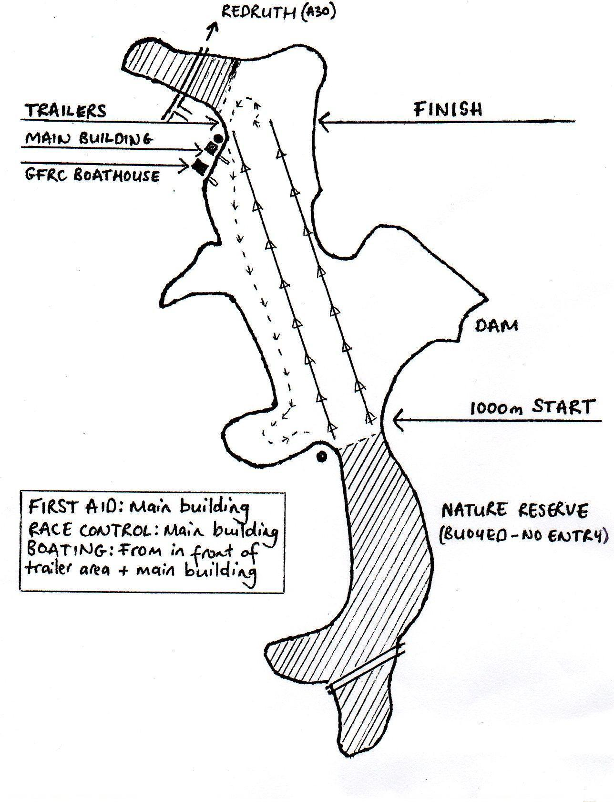

Officials briefing
An officials briefing will be held in the Watersports Centre at 10am. Crew changes and any necessary information about the course will be given to the officials at this point.
Captains and coxes briefing
The briefing for captains and coxes will take place outside the main Watersports Centre building at 10.15am. Changes to crews and important information must be given to the Regatta Secretary before 10am.
Safety checks
It is the responsibility of all competing clubs to ensure that their boats and equipment are safe and suitable for the competitors and conditions. Clubs should refer to the British Rowing Row Safe guidance. Clubs should be particularly aware of the guidelines relating to heel restraints and lifejackets.
Random checks of boats and equipment may be undertaken by GFRC officials.
Safety presence
- There will be at least two safety boats on the water in addition to the umpires’ boats.
- There is a defibrillator on-site (situated on the wall of the main Watersports Centre building)
- First Aid for minor injuries is situated in the main Watersports Centre building (in the classroom where registration takes place and refreshments are being served)
- The Medical Officer for more serious injuries or incidents is Beth Jones (GFRC member), supported if required by South West Lakes staff, land based at the main office.
Communications
All Regatta safety boats will be equipped with a VHF radio set as will Regatta Coordinators on land (located in/around the Finish Tent).
Weather conditions
The GFRC Regatta Committee will make an assessment, along with the Senior WEARA Umpire, as to the suitability of the conditions for racing for all crews or selected crews. If the Regatta goes ahead, it is the responsibility of the individual and/or club officials to make an assessment as to the ability of the crew/individual to cope with the conditions before going out on the water. In the event of high winds the regatta will be cancelled.

Incident procedure
In the event of an incident on the lake the following procedure will be adopted by all crews:
- All racing must stop.

- Regatta Coordinators will direct the nearest safety boats to the incident. All other umpires will be notified of the incident by radio from the Coordinating Umpire.

- Regatta Coordinators will take responsibility (in consultation with the event medical officer if appropriate) for contacting the appropriate emergency services

- The event Medical Officer (Beth Jones) will be advised and will proceed to the site of the incident (or to shore to await the safety boat with the casualty).

- If the incident occurs on the water then the casualty will be taken to shore using one of the two safety boats on the water.

- The event Medical Officer will cover administering first aid, assisted as required by Regatta Coordinators and other onsite First Aiders.

- Racing will only restart when the Regatta Coordinators, Senior Umpire and Safety Adviser agree to resume racing after liaising with South West Lakes staff.

- Land-based major incidents should be reported to the Regatta Coordinators at the Finish Umpires tent so that the event Medical Officer can be alerted to respond.

- We require all competing clubs to provide an emergency contact name and phone number. This person must be available for the entirety of the event and to have access to emergency contact information and any relevant medical information for all of their competing members.

- Following a minor incident on land, competitors, visitors, guests and officials are advised that the First Aid point is located in the classroom (morning registration and refreshments location). The event First Aiders will contact the the event Medical Officer if necessary.
Useful contacts:
Royal Cornwall Hospital, Truro - 01872 250000
Royal Cornwall Hospital, Truro A&E - 01872 253111
Falmouth Hospital - 01326 436600 Minor Injuries
Camborne and Redruth Hospital - 01209 318000 Minor Injuries
NHS non-emergency number: 111
Regatta Secretary: Cathy Almond – 07545 990644
Captain: Mary Coote – 07879 446785
Event Medical Officer: Beth Jones
Club Rowing Safety Adviser: Lee Clarke
Club Welfare Officer: Cathy Almond – 07545 990644
Stithians Lake Activities Centre: 01209 860301

Activity | Hazard | Likely Injury | Persons at risk | Likelihood  Low  Medium  High | Severity  Slight  Moderate  Extreme | Control Measures | Action
Delivery of boats to site | Conflict with other vehicles and people | Crushing/injury | Competitors/  general public | Low | Moderate | Remind drivers of 10mph speed limit and hazards in Safety information. | Note in Safety information.
Delivery of boats to site | Fall hazard unloading boats | Injury | Competitors/  general public | Low | Moderate | Plenty of room given for unloading. Remind clubs that they are responsible for their own safety. | Remind clubs that they are responsible for their own safety in the Safety information.
Getting boats onto the water | Slips, trips and falls | Cuts and bruises | Competitors | Medium | Slight | Warn competitors to take appropriate care in Safety information. | Note in Safety information.
Rowing to the start | Collision with other crews | Cuts and bruises | Competitors | Medium | Moderate | Indicate circulation pattern in Safety plan and point competitors to the British Rowing Row Safe guidance. | Note in Safety information and at Captains/Coxes briefing.
Rowing to the start | Capsize | Reaction to cold/Drowning | Competitors/  Officials | Medium | Moderate/  Extreme | All competitors able to swim in accordance with British Rowing Water Safety Code.  All coxes to wear life jackets in accordance with British Rowing Water Safety Code.  All equipment fit for purpose in accordance with British Rowing Water Safety Code.  Water Safety Officer to carry out safety checks on boats and equipment. | Note in Safety information about competitors referring to Row Safe Guidance.
Rowing to the start | Collision with moored boats | Cuts and bruises | Competitors | Low | Slight | Move moored boats from areas used for paddling to start and racing. | South West Lakes staff to move moored boats.
Racing | Collision with other craft | Cuts and bruises | Competitors | Low | Moderate | Umpires boat to follow all races and alert crews to hazards/potential collision. | Umpires to follow all races and be suitably sited.
Racing | Capsize | Reaction to cold/Drowning | Competitors | Medium | Moderate/  Extreme | As for rowing to the start. | Note in Safety information.
Racing | Rowing over active aeration units causing capsize | Reaction to cold/Drowning | Competitors | Medium | Moderate/  Extreme | Aeration units to be turned off for the duration of the regatta. If they come on during the regatta, course to be shortened. | Regatta officials to arrange for units to be switched off and to monitor this throughout the regatta.
Other | Hypo/Hyperthermia due to weather or immersion in water | Collapse/death | Competitors/  Officials | Low | Moderate/  Extreme | Provide first aid cover. | Provide first aid and supply incident procedure in Safety information. Remind competitors of personal responsibility for safety in information.
Other | General accidents and emergencies | Injury/illness | Competitors/Officials/General Public | Low | Slight/  Moderate | Provide first aid cover. | Provide first aid and supply incident procedure in Safety information.
Other | High winds | Water conditions unrowable leading to injury/capsize | Competitors | High | Moderate | Race Committee to abandon racing in the event of high winds so that situation does not occur. | Note in Safety information that Regatta will be cancelled in event of high winds.
Risk Assessment

